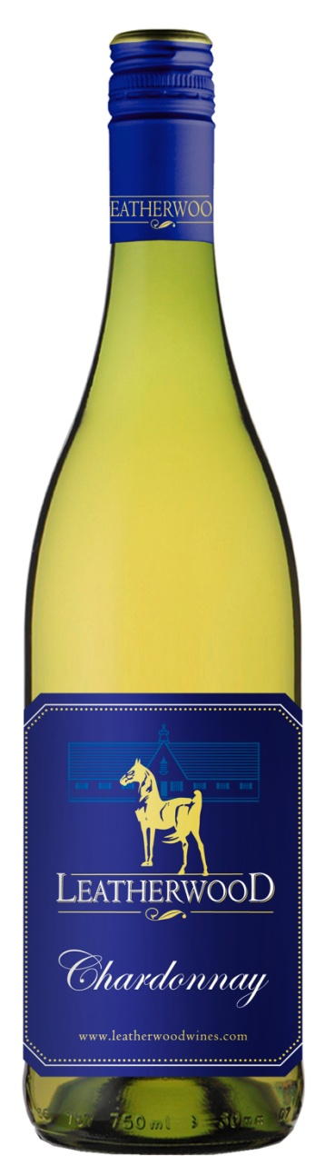
Leatherwood Chardonnay’16

Technical Analysis
Blend: 100% Chardonnay
Winemaker: Chris de Wet
Appellation: Western Cape, South Africa
Yield: 10 tons/acre
Harvested: 2/28/2016
Production: 10,000 cases
Aging: 75% Steel Tank, 25% new French Oak.
Brix: 23
Alc 13.0
Ph: 3.11
RS: 5.2 gr/L
TA: 7.4
Tasting Notes:
The nose shows hints of peach, lemons and orange blossom backed up by a touch of oak. The palate is fresh and creamy with great length from the acidity. 3 months of lees contact gave greater fullness to the wine. Lightly wooded Chardonnay makes for the perfect companion to rich foods such as poultry in a cream sauce, fish and pasta dishes but crispy enough to be enjoyed on its own.
2016 WORLD WINE CHAMPIONSHIPS AWARD: Silver Medal

Vineyard Varieties
Dublin, VA

