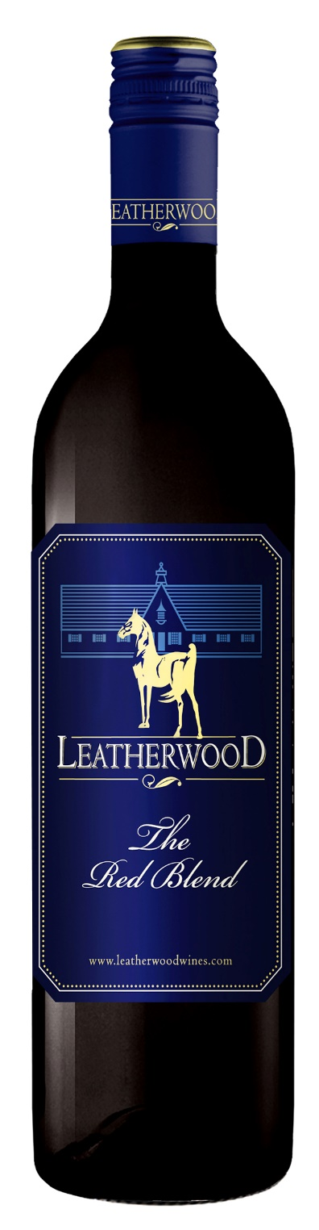
Leatherwood
2014
The Red Blend
Blend: 67% Cab Sauv, 15% Cab Franc, 10% Merlot, 8% Petit Verdot
Winemaker: Chris de Wet
Alcohol: 14% vol
RS: 4.9 g/l
Total Acid: 5.85 g/l
Brix: 24.0
Yield: 8 tons’/acre average on all varietals
Production: 12,000 cases
Oak Type: French Barriques
Oak Age: 100 % 2nd fill
Time in Oak: 12 months
Harvested: 3/8/2014
Appellation: Western Cape, South Africa

Tasting Notes: Produced from our cool-climate, high-elevation slopes containing a mixture of gravelly and limestone soils. Hand harvested and fermented on the skins. The resulting wine is fruit-forward, succulent and delicious. The Petit Verdot and Cabernet Franc adds texture and savory notes of dried herbs and smoked meat. Good stuff! The resulting wine is fruit-forward, succulent and delicious. I particularly appreciate the Petit Verdot and Cabernet Franc, which adds texture and savory notes of dried herbs and smoked meat. Good stuff!

Vineyard Varieties
Dublin, VA

