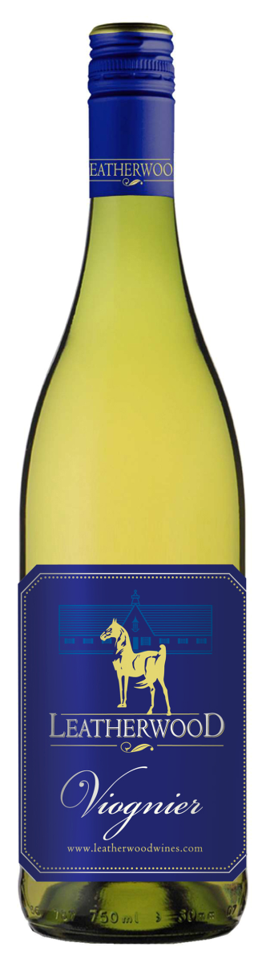
Leatherwood Viognier 2017
Blend: 100% Viognier
Winemaker: Chris de Wet
Appellation: Western Cape, South Africa
Yield: 10 tons/acre
Harvested: 2/12/2017
Production: 5000 cases
Aging: Steel Tank with a late-harvested batch blended in for extra richness.
Brix: 24
Alc 13.9
Ph: 3.02
RS: 6.0 g/L
TA: 7.7
Beverage Testing Institute Ratings:
Tangerine, mango, golden pineapple and cantaloupe compliment a honey noted but dry supple palate with a medium body and ripe balanced finish. Has just enough acidity to balance the cornucopia of fruit, but could not be described as crisp.
2016 BTI WORLD WINE CHAMPIONSHIPS AWARD:
GOLD MEDAL; 93 POINTS; BEST BUY; HIGHLY RECOMMENDED
Food Suggestion:
The highly aromatic and fruit forward nature of Viognier partners very well with Thai food. It latches onto to ginger with enthusiasm and the muskiness of Viognier also leads to an affinity with mushrooms.

www.vineyardvarieties.com

