Prospect
1870 Red Blend
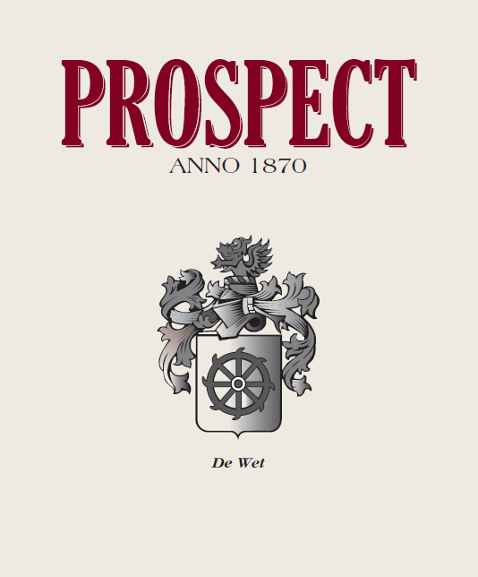
Total Acid: 6 g/l
Balling/Brix: 26.4°
Yield: 3.6 tons/acre
Production: 150 cases
Oak Type: French Feuilettes
Oak Age: 100% new
Time in Oak: 24 months
Appellation: Robertson, South Africa
Harvest date: 3/15/2007
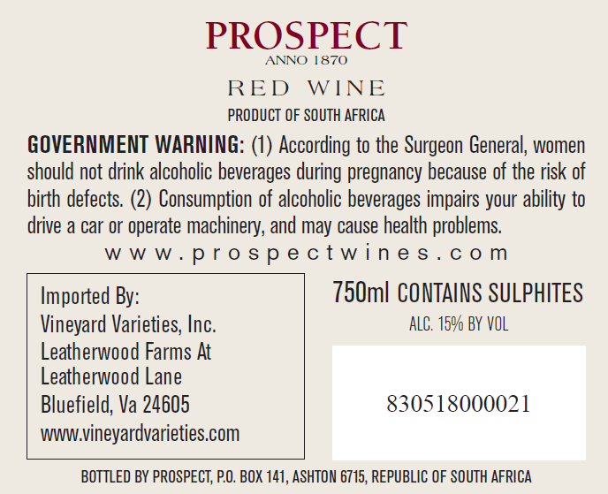

Awards: 89 pts – Wine Enthusiast Magazine
Winemaker: Chris de Wet
Alcohol: 15% vol
RS: 2.74 g/l

Blend Information: 80% Cabernet Sauvignon / 20% Shiraz

Reviews: This bright, fruity blend starts with aromas of toasted vanilla and black cherry, followed by a rich, dark chocolate-covered cherry and spice palate. Anise and spice add to the appeal. A wine with aging potential that could also be drunk now with the right dish. – S.K. (12/31/2009) – 89

De Wet’s Toast of Kentucky
4223 Lexington Rd. Suite J
Paris, KY 40362

